1.

The SQL DML provides the ability to query information from the database and to insert tuples into, delete tuples from, and modify tuples in the database.

The SQL DDL provides commands for defining relation schemas, deleting relations, and modifying relation schemas.

DML commands

a) CREATE TABLE, ALTER TABLE, DROP TABLE

b) SELECT, INSERT, UPDATE, DELETE

Example 1:

DDL commands:

CREATE TABLE database university_db  
 tablespace teacher;

AFTER TABLE instructor   
 alter column name type varchar(100) ;

DROP databases university_db;

DML commands:

INSERT INTO deportment database (name, building)  
 VALUES( ‘BS’ , ‘KBTU’ );

DELETE  
 from department_child

SELECT*  
 from department;

UPDATE table_name SET column1 = value1 , column2 = value2 , …  
 WHERE condition;

2.CREATE TABLE customers  
( ID INT PRIMARY KEY,

full_name VARCHAR(50),  
from_date DATE PRIMARY KEY, to_date DATE

);  
CREATE TABLE products(

ID varchar PRIMARY KEY,  
name varchar , is _paid PRIMARY KEY, description TEXT ,price double precision ;

);  
CREATE TABLE orders(

code INT PRIMARY KEY, customer_id INT,   
total_sum double precision, is_paid BOOL;

);  
CREATE TABLE order_items (

order code INT , product_id varchar, constraint id PRIMARY KEY(order code , product_id), foreign key (order_code) references orders (code) , foreign key (product_id) references products (id)   
to_date DATE,

);  
CREATE TABLE dept_emp(

code INT PRIMARY KEY, dept_no CHAR(4) PRIMARY KEY, from_date DATE,  
to_date DATE

);  
CREATE TABLE departments(

dept_no CHAR(4) PRIMARY KEY, dept_name VARCHAR(40)

);

|  |  |
| --- | --- |
| |  | | --- | | ); | |

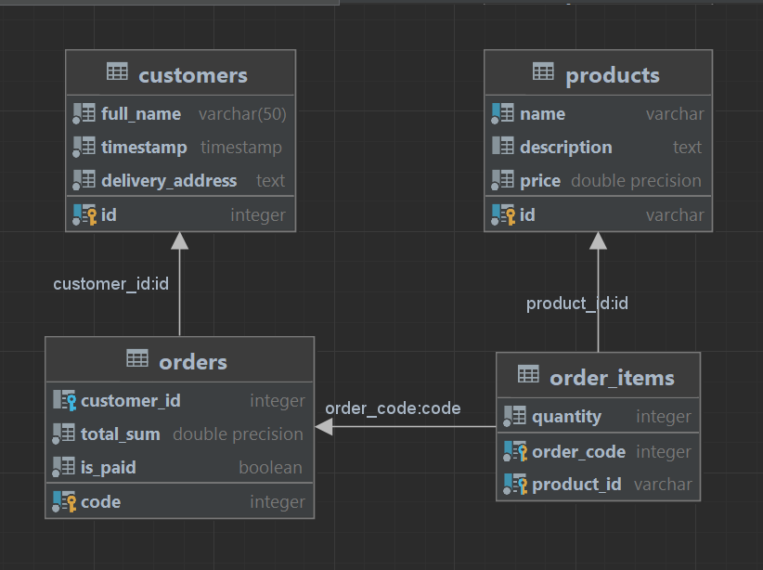

3. a) CREATE TABLE students (  
full_name VARCHAR(30),  
birth_date DATE,  
average_grade FLOAT,

age INT,  
birth_date DATE,  
gender CHAR(10),  
gpa INT,

phone_number INT, social_category VARCHAR(50)

);  
b) CREATE TABLE instructors  
( full_name VARCHAR(30),

languages VARCHAR(100), experience INT, possibility_of_having_lessons BOOL

);  
c)CREATE TABLE student_relatives  
( full_name VARCHAR(30),

address VARCHAR(20), phone_number INT, position CHAR(10)

);  
d)CREATE TABLE student social data ( school VARCHAR(20),

graduation_data DATA, address VARCHAR(20), region VARCHAR(15), country CHAR(10),

gpa INT,  
honors VARCHAR(50)

);

4. INSERT into customer VALUES(‘Jack’, ‘Databases’ , ‘Ilon ‘) ; INSERT into order_items VALUES  
(10247, 500000, 2015, 2022)

UPDATE title SET

UPDATE customers set full_name = “Ilom Mask’ where id = 75;

DELETE gender FROM employees

DELETE from customers where id = 100 ;